Application Number | 07/2018/0979/FUL
Address | 8B Centurion Court  Farington  Leyland  Lancashire  PR25 3UQ
Applicant | Kevin Morris
Development | Change of use from Class B1/B2/B8 (Business/General industry and storage to Class D2 (Leisure) - Gym
Officer Recommendation  Officer Name | Approval with Conditions  Mrs Janice Crook
Date application valid | 21.02.2018
Target Determination Date | 18.04.2018
Extension of Time | 27.04.2018
Location Plan

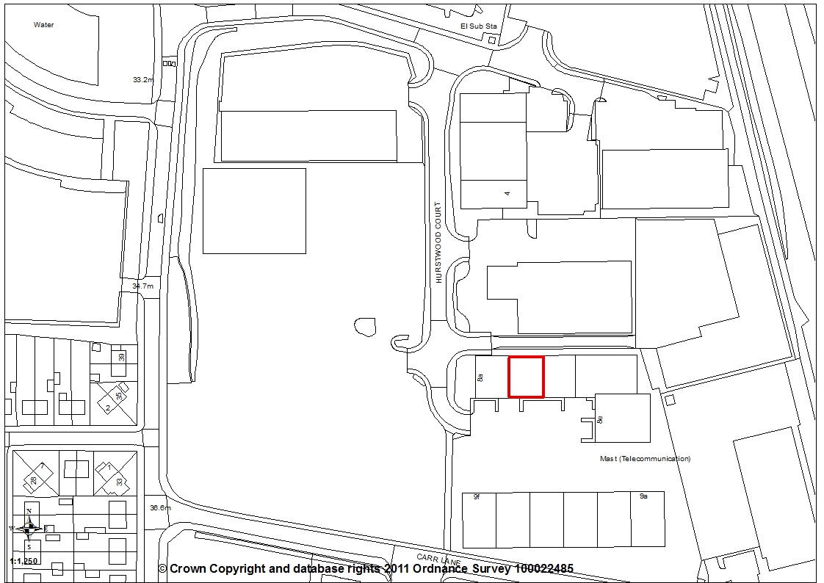

- Report Summary

  - This application falls for determination by planning committee as the applicant is related to two members of staff.

  - The application proposes the change of use of an existing industrial unit within the B Use Classes to a gym within the D2 Leisure Use Class. Policy E2 in the South Ribble Local plan seeks to protect employment premises for employment uses and Core Strategy Policy 10 sets out a number of criteria that change of use applications must meet if a change of use is required. It is considered that, in broad terms, the aims of these two policies are met and with the inclusion of a condition to ensure that the premises returns to B1, B2, B8 Uses should the proposed gym not be successful, then there will be no loss of employment premises in the long terms. The application is therefore recommended for approval subject to the imposition of conditions.

- Site and Surrounding Area

2.1 The application relates to a purpose built industrial unit located on Centurion Court, part of the Carr Lane Employment Area in Farington. The unit is within a row of similar units with adjacent uses being a family martial arts centre, Frank Brierley Power Tools and Jump UK Gymnastics and Trampoline Center. A parking court is to the front with further industrial units opposite.

- Planning History

3.1 There is no planning history relating to this particular unit.

- Proposal

4.1 The unit was last used for industrial storage and the application proposes the change of use of the unit from Use Classes B1, B2 and B8 to a D2 Leisure use. The applicant proposes to open a gym facility for strength and conditioning facility for strongman/woman training, bodybuilding and fitness regimes. The facility will employ 1 full time and 3 part time employees.

- Summary of Publicity

5.1 Neighbouring premises were notified and a site notice posted with no letters of representation being received.

- Summary of Consultations

6.1 Environmental Health have no comments to make on this application.

6.2 County Highways have no objections and are of the opinion that the development should have a negligible impact on highway safety and capacity in the immediate vicinity of the site. They also consider that adequate parking is provided for the type and size of development as the expected peak period for the gym use would not be the same peak periods for the existing adjacent commercial buildings.

6.3 Economic Development comment that the proposed change of use to a gym will only deliver 2 FTE jobs, which is a low density for a unit of this size. However, it is understood that the plans are to attract additional, indirect, jobs through personal trainers using the facilities. There are concerns about the loss of B1/B2/B8 space in this location, but recognise the potential of this business. Therefore they have no objection provided the unit returns to its original uses if and when the gym ceases occupation.

- Policy Considerations

7.1 Central Lancashire Core Strategy
The application site is within the Carr Lane Employment Area where Policy 10: Employment Premises and Sites has a set of criteria that proposes for uses other than B use class employment will need to address. These are as follows:
  - there would not be an unacceptable reduction on the type, quality or quantity of employment land supply;
  - the provision and need for the proposed use;
  - the relative suitability of the site for employment and for the alternative use;
  - the location of the site and its relationship to other uses;
  - whether the ability to accommodate smaller scale requirements would be compromised;
  - there would be a net improvement in amenity.

7.2 Central Lancashire Supplementary Planning Documents
The Controlling Re-Use of Employment Premises SPD develops Policy 10 by setting out the balanced criteria based approach under which all proposals for re-use of employment premises will be assessed.

7.3 Policy E2: Protection of Employment Areas and Sites protects land for employment uses including business, general industrial or storage and distribution within Use Classes B1, B2 and B8.

7.4 Policy G17: Design Criteria for New Development permits new development, including extensions and free standing structures, provided that, the proposal does not have a detrimental impact on the existing building, neighbouring buildings or on the street scene; does not cause harm to neighbouring property by leading to undue overlooking, overshadowing or have an overbearing effect; the layout, design and landscaping of all elements of the proposal, including any internal roads, car parking, footpaths and open spaces, are of a high quality and will provide an interesting visual environment which respects the character of the site and local area; the development would not prejudice highway safety, pedestrian safety, the free flow of traffic, and would not reduce the number of on-site parking spaces to below the standards stated in Policy F1, unless there are other material considerations which justify the reduction such as proximity to a public car park.

- Material Considerations

8.1 The application seeks to change use of Unit 8B Centurion Court which has been used for industrial storage to a gym facility. The applicant has provided a supporting statement which sets out how the proposal addresses criteria a) to f) in Core Strategy Policy 10, as follows:

- “Changing from industrial storage to a leisure use would not have a reduction on the type, quality or employment land supply.
- Even though public and community uses are best suited in town, district and local centres, as supported by the NPPF, the location is perfect for this proposal and other locations have been exhausted going through council properties and private properties using various estate agents and having looked at site within Leyland town centre.
- The change of use would fit in perfectly with surrounding businesses and would contribute to employment
- The location would also mean that there would be no impact on residential area, ie, noise, increase parking
- The need for the use of local businesses would also be of beneficial advantages, ie clothing printed, stock bought in.
- Giving a place for a friendly and safe environment for members to come and train no matter what stage they are at or ability.”

8.2 In consideration of the policy requirements and criteria a) to f):

(a) there would not be an unacceptable reduction on the type, quality or quantity of employment land supply;
It is considered that, with the inclusion of a suitably worded planning condition requiring that any permission granted is for the use applied for only and should this use cease, the premises return to B1, B2 B8 use. Therefore there would be no reduction in employment land in the longer-term.

(b) the provision and need for the proposed use;
The applicant has indicated that the nature of the strength and conditioning gym meets a number of the Council’s and Government’s guidelines in order to promote health and well-being and provide alternative forms of exercise. The applicant has identified a need for the proposed use is in order to develop the health of residents of the Leyland area.

(c) the relative suitability of the site for employment and for the alternative use;
The applicant considers the building would be an ideal for the business as it is a modern industrial unit of steel portal frame construction and reinforced concrete floor. It is just minutes away from 3 motorways and is just 5 minutes form Leyland Town Centre. Units already on the site include a Martial Arts centre, Gymnastics Centre which sit side by side with commercial businesses such as Leyland van hire, Removax security solutions. The site is a well-established industrial estate with other leisure business already trading on it. Parking is not an issue with ample communal parking and peak times for the proposed use being out of hours.

(d) the location of the site and its relationship to other uses;
The unit is within a block of similar units within the Centurion Court complex which is set to the southern part of the Carr Lane Employment Area. The applicant considers the building would be an ideal fit for the business model as it is only 5 minutes from Leyland town centre and close to 3 motorways. Parking is not an issue with ample communal parking and peak times for the proposed use being out of hours. Additionally, two neighbouring units are already within the D2 Leisure Use Class and therefore it is considered there will be no conflict with existing uses.

(e) whether the ability to accommodate smaller scale requirements would be compromised;
There are no alterations proposed to the unit and therefore the ability for the unit to accommodate smaller scale uses if necessary in the future is not compromised. Should the use as a gym facility be unsuccessful, there is nothing to prevent the unit from reverting back to employment use and, if necessary, can be subdivided to meet particular needs.

(f) there would be a net improvement in amenity.

The unit is currently vacant. However, it has only be unoccupied since February this year and it is considered to be preferable to have the unit occupied rather than remain vacant, it has not been marketed for its intended use as an industrial unit for a suitable length of time. It is considered that the very fact that the unit is occupied would result in an improvement in the amenity of the area.

8.3 In consideration of the loss of this unit from B1/B2/B8 use to a leisure use within the D2 Use Class, Economic Development have commented that demand for commercial sites and premises is high in South Ribble. The recent Central Lancashire Employment Land and Property Study identified 93% occupancy of industrial units overall. The Study was commissioned to assess the demand for commercial premises and the required supply of property in South Ribble to deliver economic growth.

8.4 The proposed change of use to a gym will only deliver 2 FTE jobs, which is a low density for a 2,885 square foot (268 square metre) unit. However, Economic Development understand that this project also plans to attract additional, indirect, jobs through personal trainers using the facilities. Additionally, this business has accessed business support to help them grow a sustainable operation.

8.5 Economic Development have concerns about the loss of B1/B2/B8 space in this location, but recognise the potential of this business using the space. Therefore they have no objection provided the unit returns to its original use when the gym ceases occupation.

9. Conclusion

9.1 For the reasons outlined above, it is considered that the proposed change of use from employment to D2 leisure use accords with the criteria set out in Policy 10 of the Core Strategy. The application is therefore recommended for approval with the inclusion of a suitably worded condition to ensure that the unit reverts back to uses within the B Use Class should the proposed use cease to operate in the future to safeguard the unit for employment uses.

10. Recommendation

10.1 Approval with Conditions.

11. Recommended Conditions

1. The development hereby permitted must be begun not later than the expiration of three years beginning with the date of this permission.
REASON: Required to be imposed pursuant to Section 91 of the Town and Country Planning Act 1990.

2. The use hereby permitted shall be restricted to the use as a gym facility as applied for. Should the use of the building as a gym facility cease, the building shall be returned to its previous use within the B Use Classes contained in The Town and Country Planning (Use Classes) Order 1987 (as amended) within 3 months unless otherwise agreed in writing with the Local Planning Authority.
REASON: In order that the Local Planning Authority can retain control over the future use of the building, in accordance with Policy E2 in the South Ribble Local Plan 2012-2026

12. Relevant Policy

Central Lancashire Core Strategy
Policy 10: Employment Premises and Sites

South Ribble Local Plan
E2: Protection of Employment Areas and Sites
G17: Design Criteria for New Development

Supplementary Planning Document
Employment Premises

